**Allsop Api**

Class Diagram

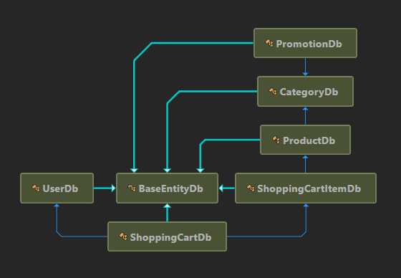

Project Dependences

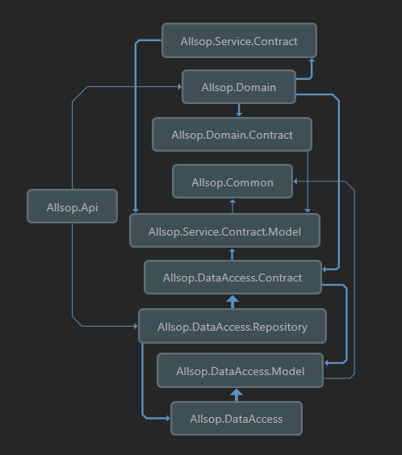

Allsop use memory database and it automatically generate test data when Allsop Api is launched.

About test data:

* It has 3 Users used to test shopping cart:

ID 1: 1163ECBA-656F-4A4E-BB81-52E9F81954BA

For the test case:

Get 10% off bulk drinks – any drinks are 10% off the listed price (including already reduced items) when buying 10 or more

ID 2: 3DF98345-AD3E-4ECA-AC83-7BF12FBFF3D2

For the test case:

£5.00 off your order when spending £50.00 or more on Baking/Cooking Ingredients

ID 3: DFE72135-05EB-41A3-8C96-26728B0DA83B

For the test case:

£20.00 off your total order value when spending £100.00 or more and using the code 20OFFPROMO”

* It has 3 promotions based on user requirements
* It has category and product data based on requirements
* It has three shopping carts include shopping cart items with above user Id

Start Allsop Api: open Allsop solution in VS2019/VS2022 then hit F5 to start API, after API is launched, a webpage is load with the link: https://localhost:7226/swagger/index.html

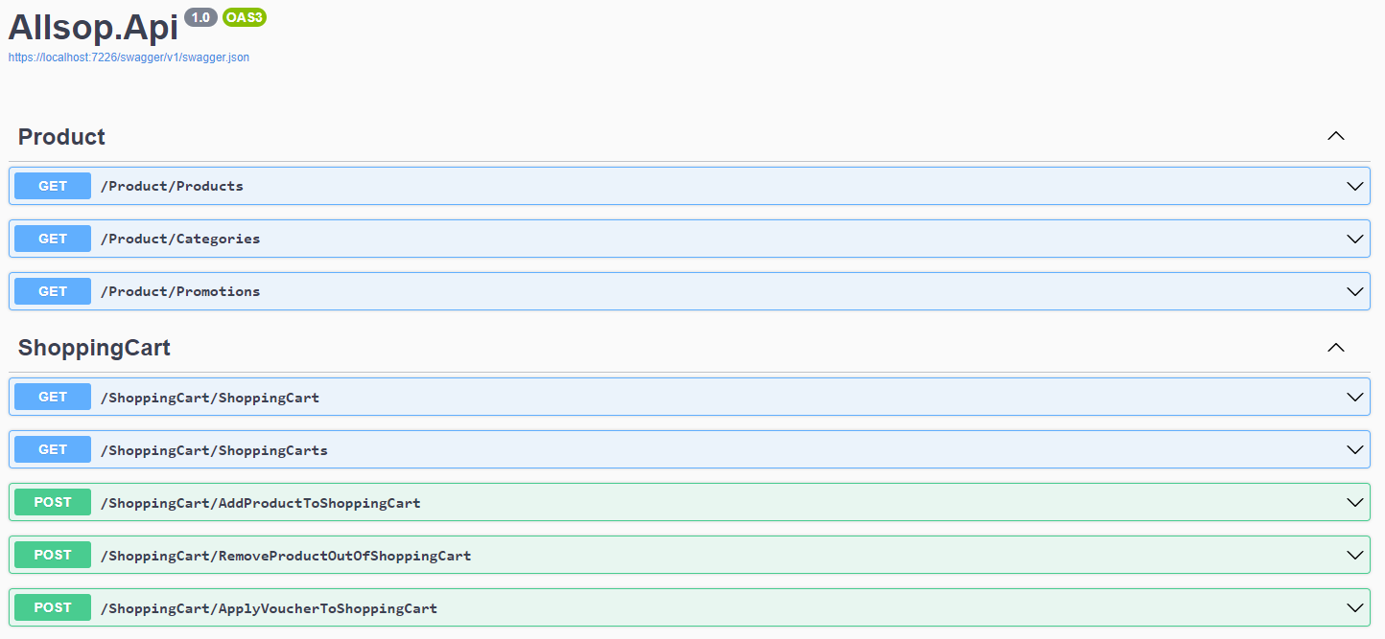

Test the use cases:

1. As a User I can view the products and their category, price and availability information.

Hit on the Api Get Products, then hit the button ‘Try it out’

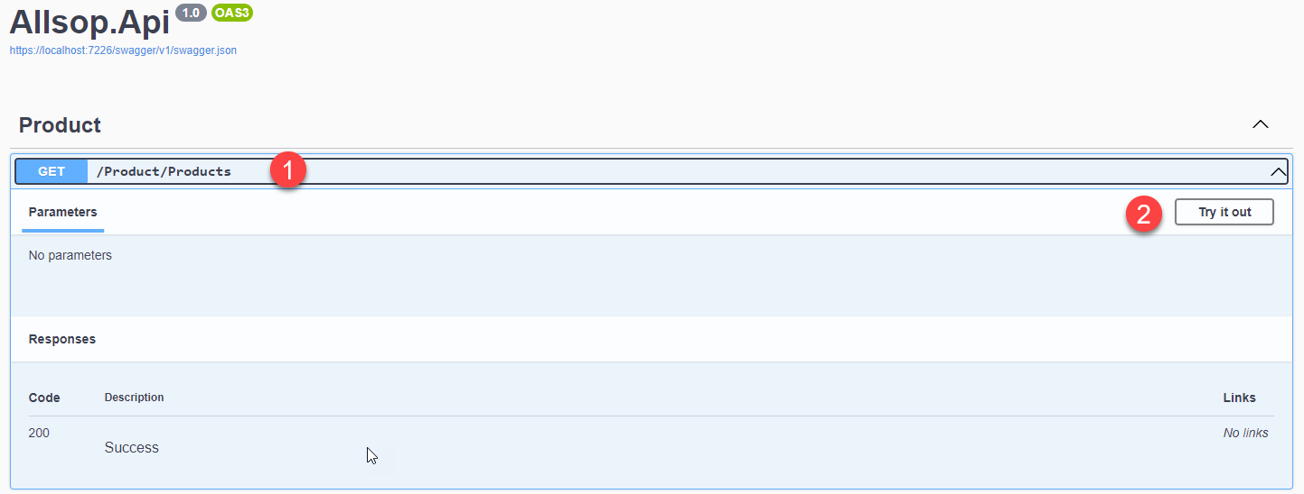

Finally hit on the button ‘Execute’ to call the api

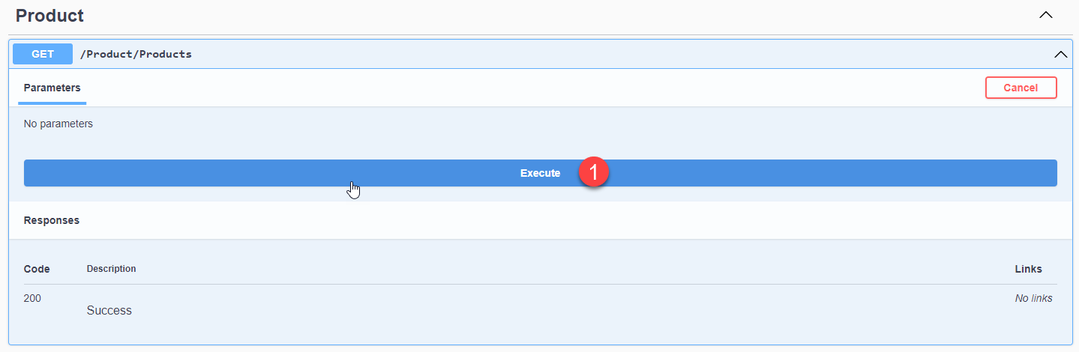

The output:

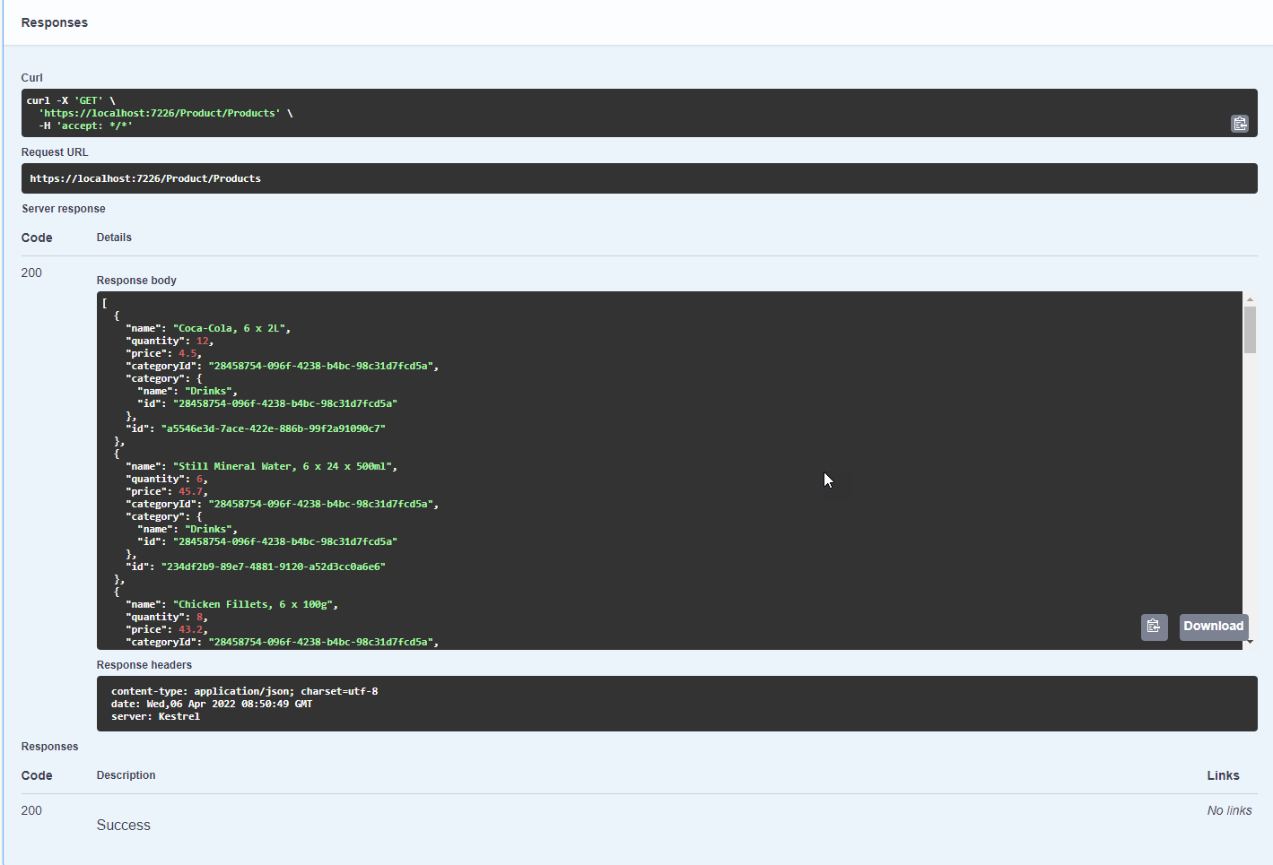

1. As a User I can add a product to my shopping cart.

Input:

* + ProductId: any product Id in the list test products
  + Quantity: any number from 0-255
  + UserId: any 3 users above

Output:

* + If product exists in shopping cart items, its quantity should be update.
  + If product does not exist in shopping cart items, this product should be add to shopping cart item.
  + Discount should be calculate based on the requirements.

Exception should throw in these cases:

* + Product Id does not exist
  + User id does not exist (shopping cart does not exist)

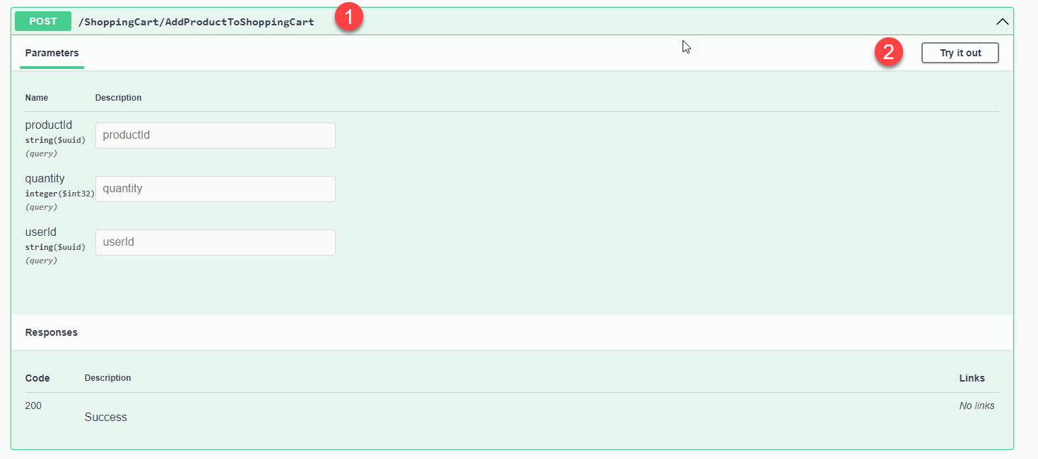

Input ProductId, Quantity and UserId then hit the ‘Execute’ button

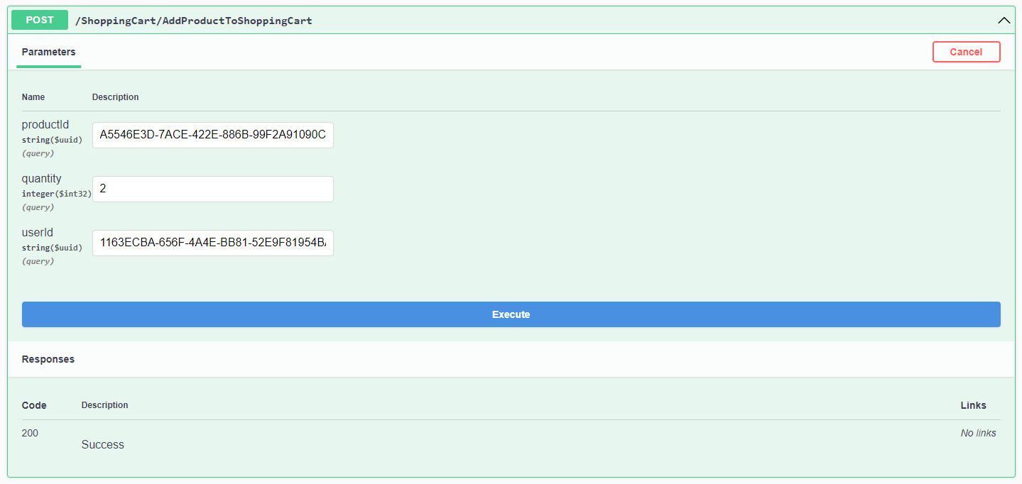

The output:

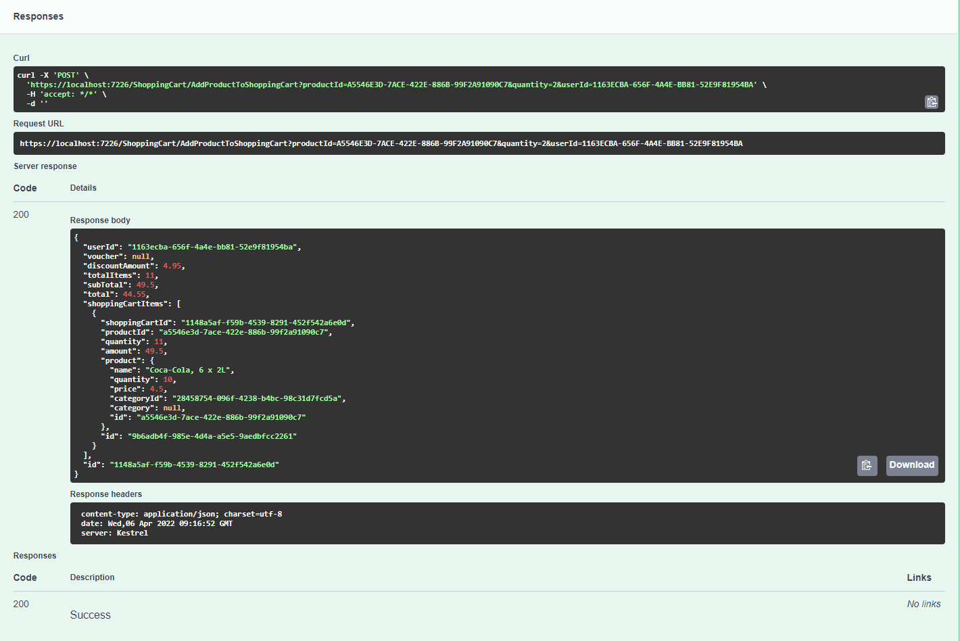

1. As a User I can remove a product from my shopping cart.

Input:

* + ProductId: any product Id in the list test products
  + Quantity: any number from 0-255
  + UserId: any 3 users above

Output:

* + If quantity of product <= quantity of this product in the shopping cart item then quantity in shopping cart item should be update
  + If quantity of product > quantity in shopping cart item this item should be remove out of shopping cart item
  + Discount should be calculate based on the requirements

Exception should throw in these cases:

* + Product Id does not exist
  + User id does not exist (shopping cart does not exist)

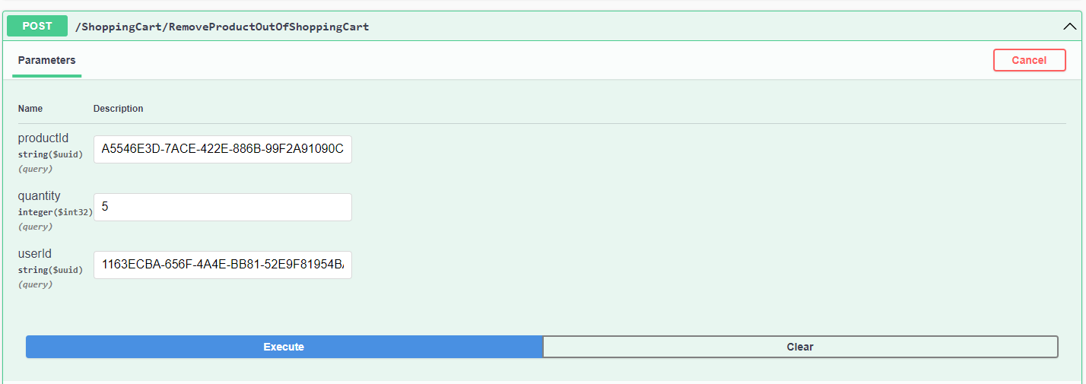

The output:

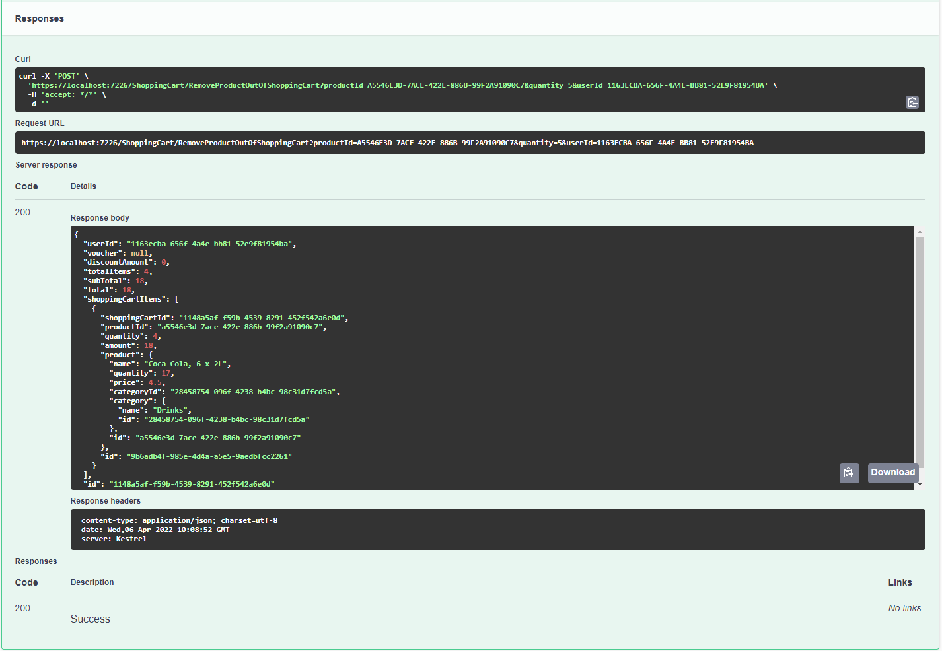

1. As a User I can view the total price for the products in my shopping cart.

Input: User Id

Output: shopping card include shopping cart item within product and category

Exception:

* + Shopping cart does not exist with given User Id

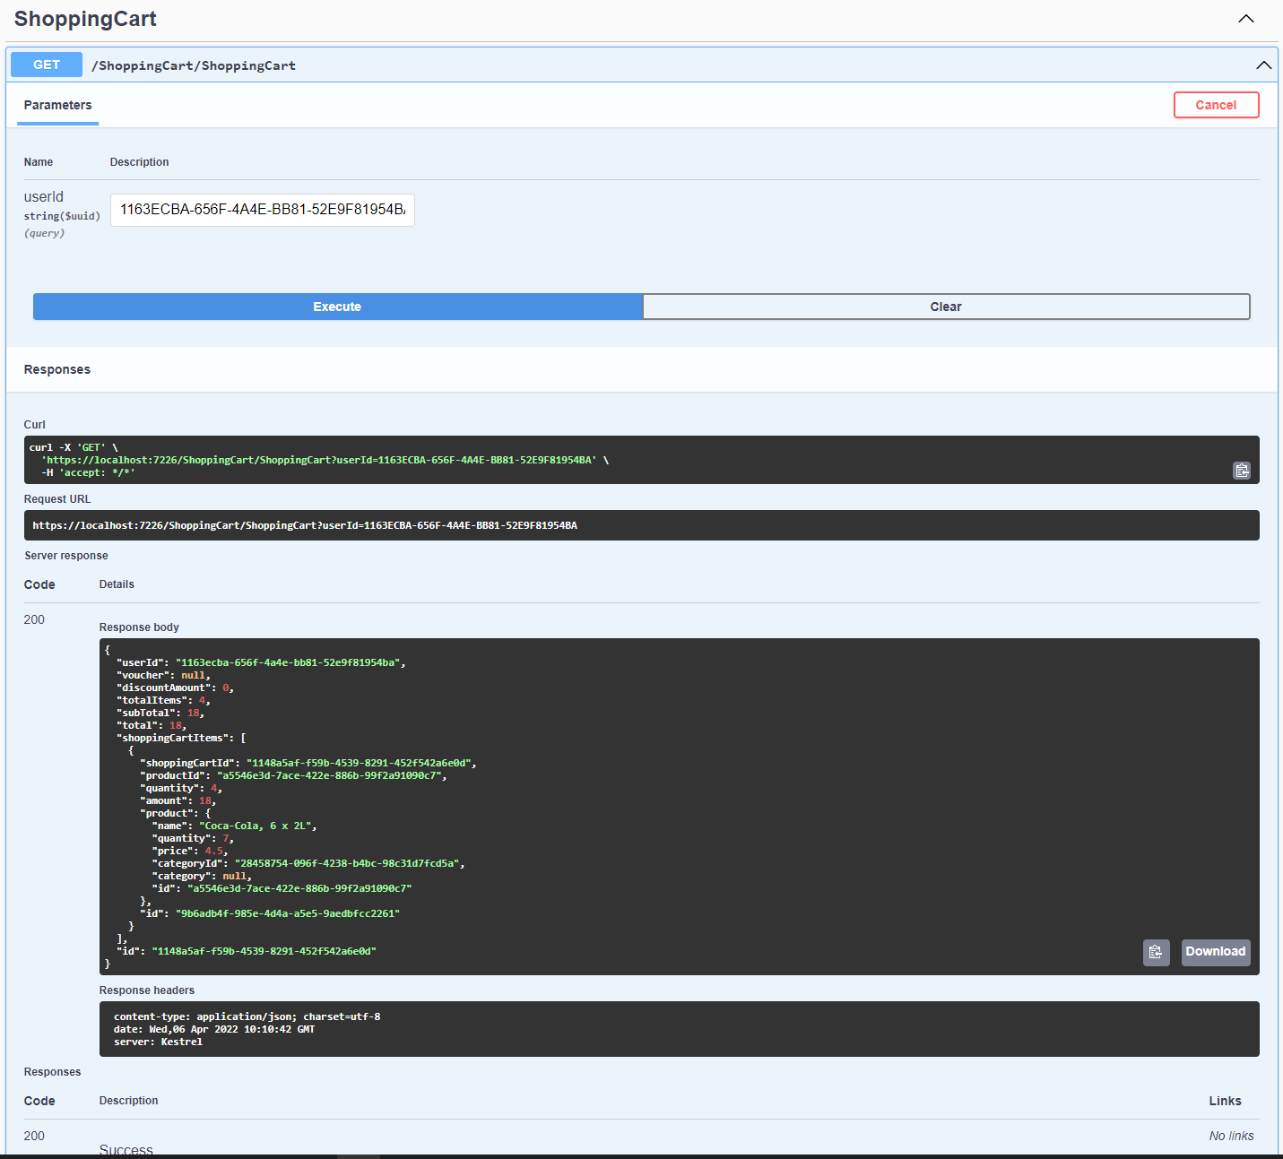

1. As a User I can apply a voucher to my shopping cart.

Input:

* + Voucher: any string
  + User Id

Output:

* + Voucher should be apply to shopping cart
  + Discount should be calculate

Exceptions:

* + Voucher does not exist in promotions
  + Shopping cart does not exist with given User Id

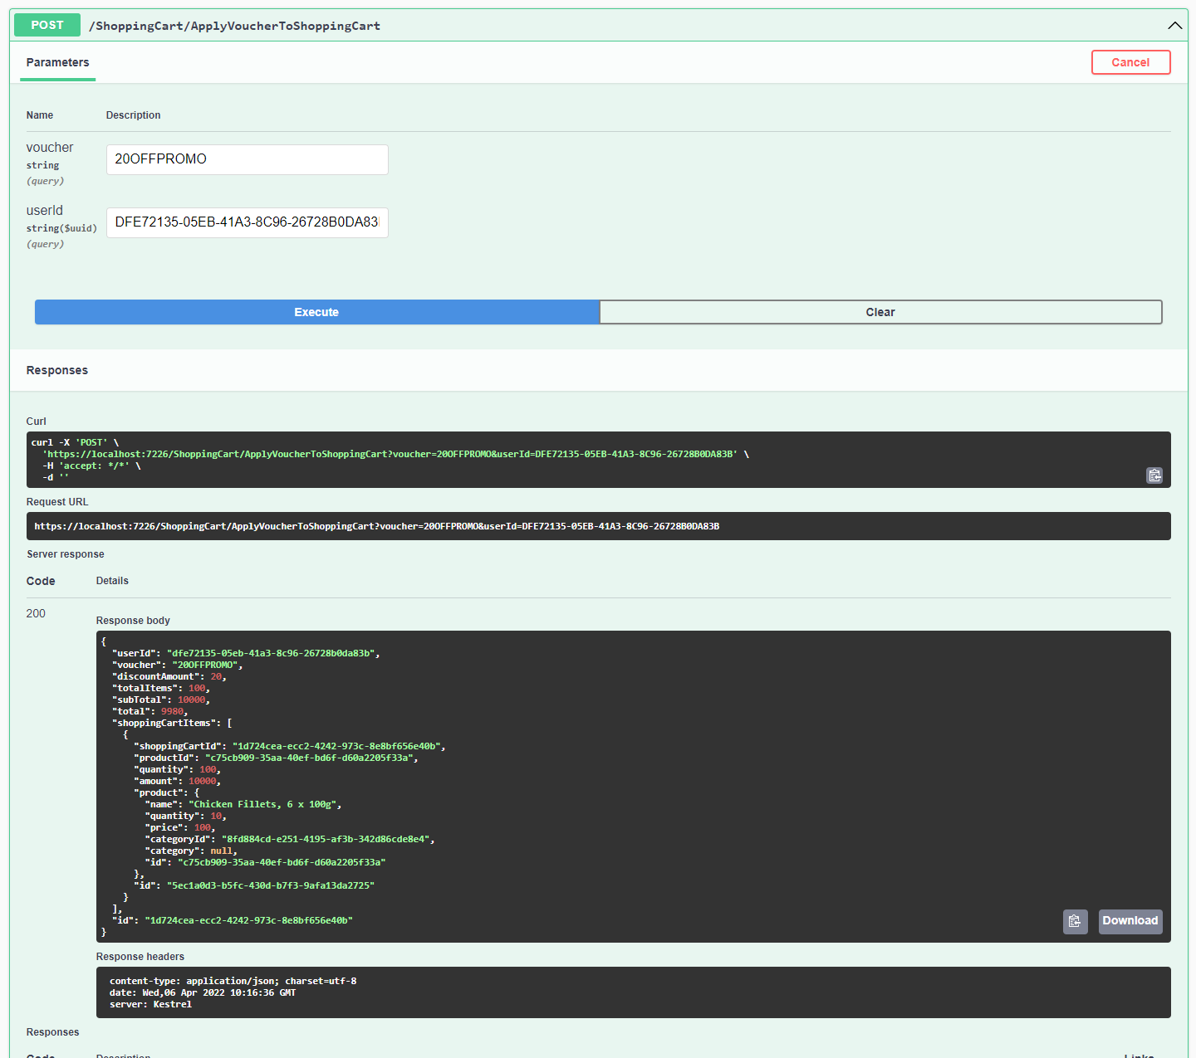

1. As a User I can view the total price for the products in my shopping cart with discounts applied.

Same as use case {4}

1. As a User I am alerted when I apply an invalid voucher to my shopping cart. 8. As a User I am unable to Out of Stock products to the shopping cart.

